AWS WAF

AWS WAF ia web application firewall that lets you monitor http and https requests that are forwarded to the protected web application resources

The following resourse types can be protected by AWS WAF

- Cloudfront distribution
- Api gateway rest api
- Application load balancer
- Aws app sync grqphql api
- App cognito user pool
- Aws app runner service
- Aws verifies access instance
- Aws amplify

WAF will let us control the access to our content
- Block all except the one we specify
- Allow all except the one we specify
- Count request that match our criteria
- Run captcha or challenge checks against request that matches our criteria

AWS SHIELD ADVANCED

it can decrease the effect of DDOS

It has two types of shields
- Aws shield standard
- Aws shield advanced

AWS FIREWALL MANAGER
It simplifies our administration and maintenance tasks across various accounts or resources for variety of protection, WAF,SHEILD ADVANCED,ROUTE53 RESOLVER DNS FIREWALL, VPC SECURITY GROUPS AND NACL’S, AWS NETWORK FIREWALL.
With firewall manager we setup once and the service automatically applies.

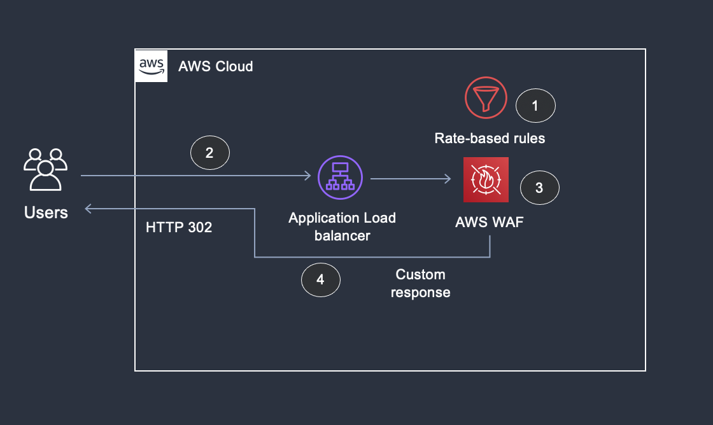

Creating a new waf for the alb

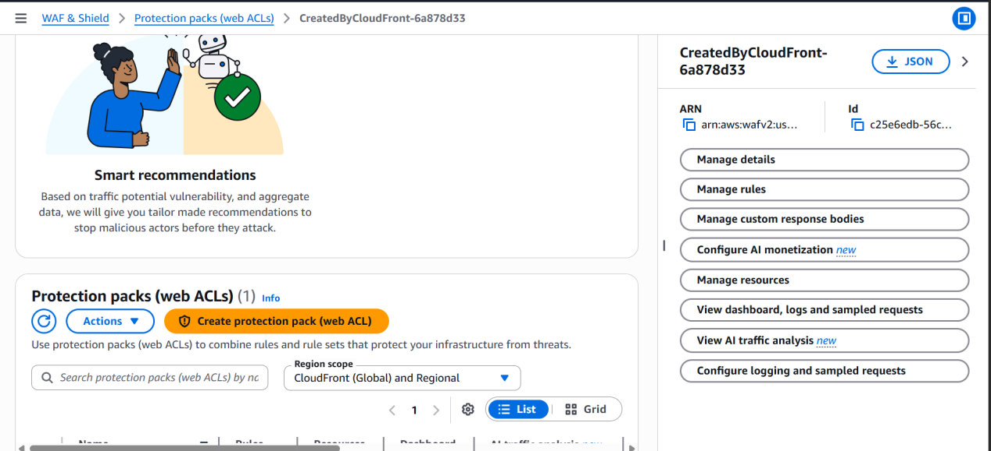

I can add my resources I have my alb so I will be giving my alb

If I have cloudfront distribution then I can add the distribution

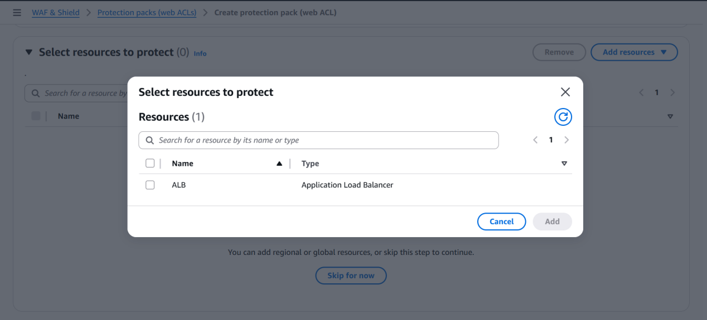

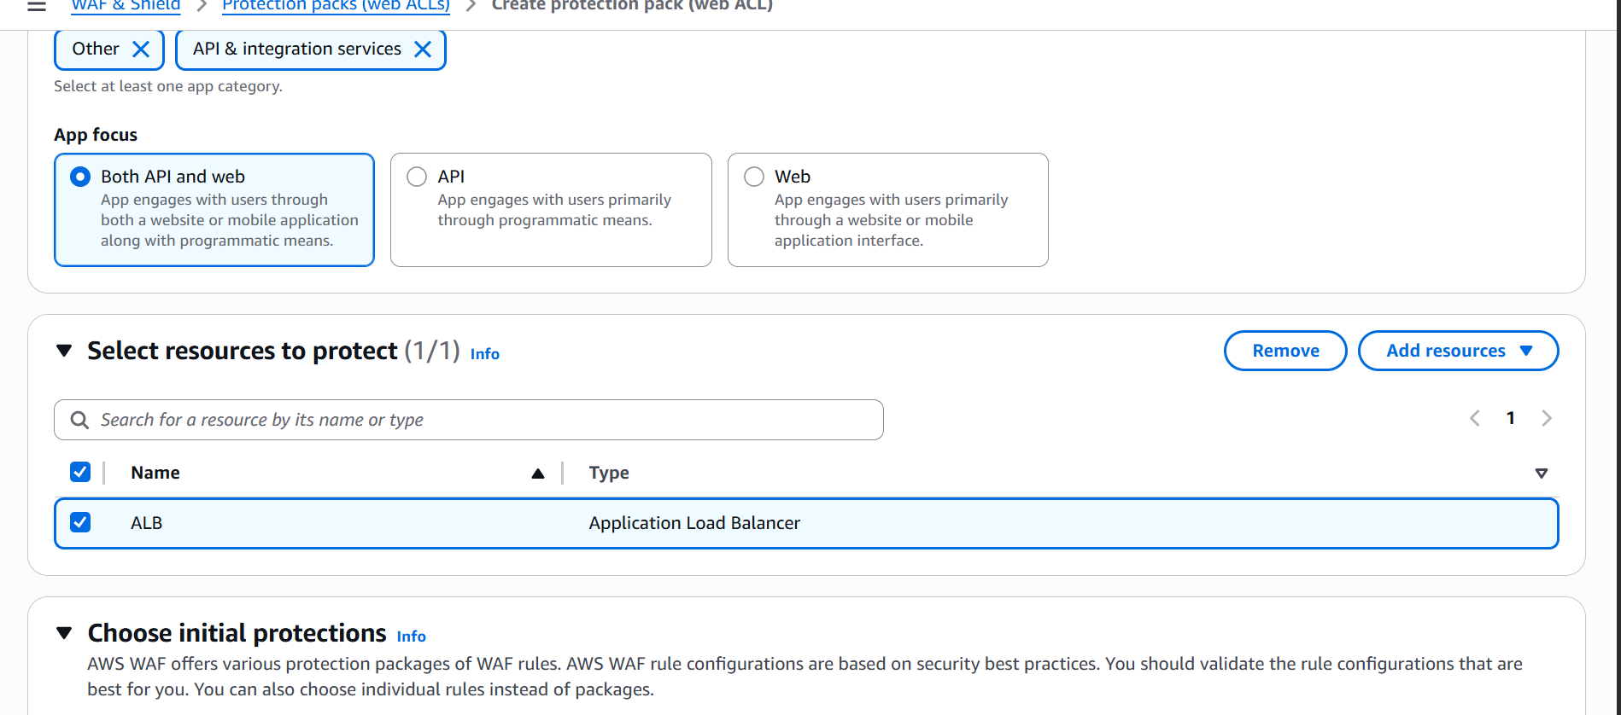

I can block or allow any particualar ip address

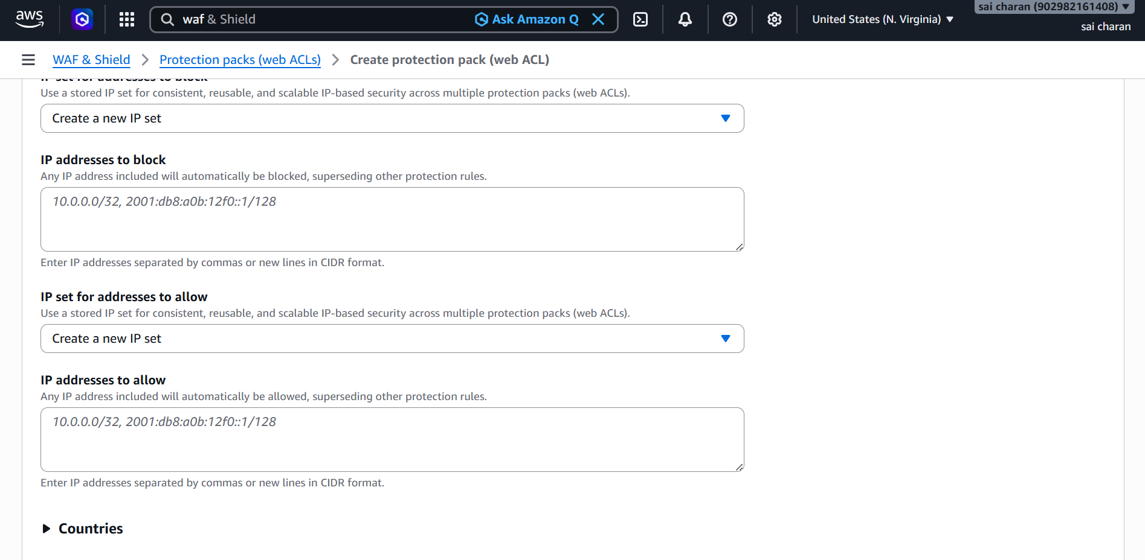

I block or count requests from countries or geographical location of the users

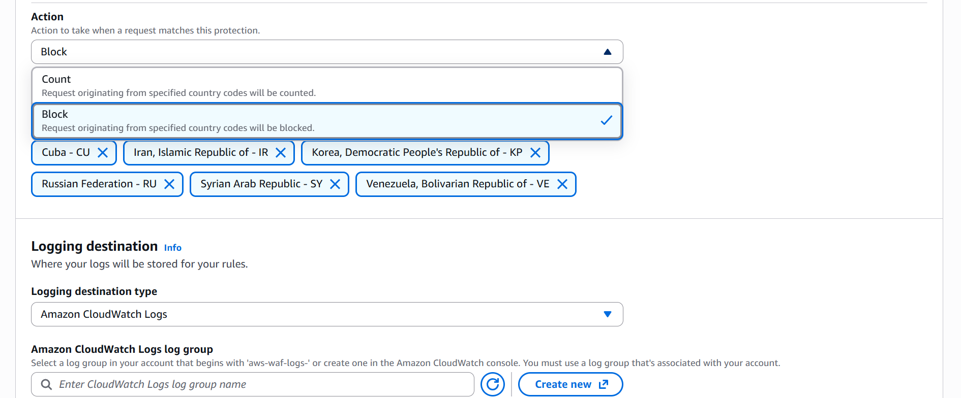

Create a new log group with exact same name as shown

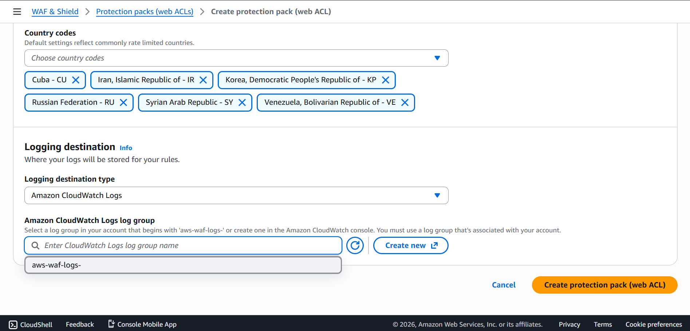

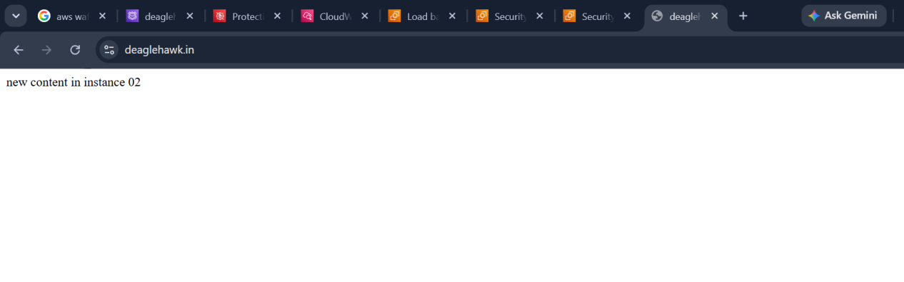

I have created my domain name to route 53 and using alias forwarded the traffic to load balancer and using security groups I have made my connection strictly flows from browser to waf to load balancer to ec2

Edited listener rules in load balancer so that user using my load balancer dns cant access to the ec2 instead they should use domain name and then automatically the request will be taken to waf

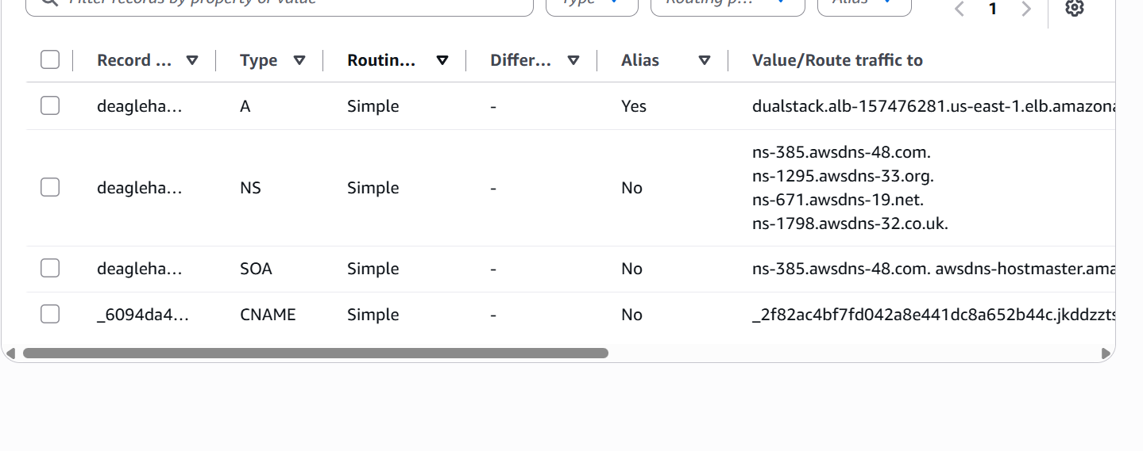
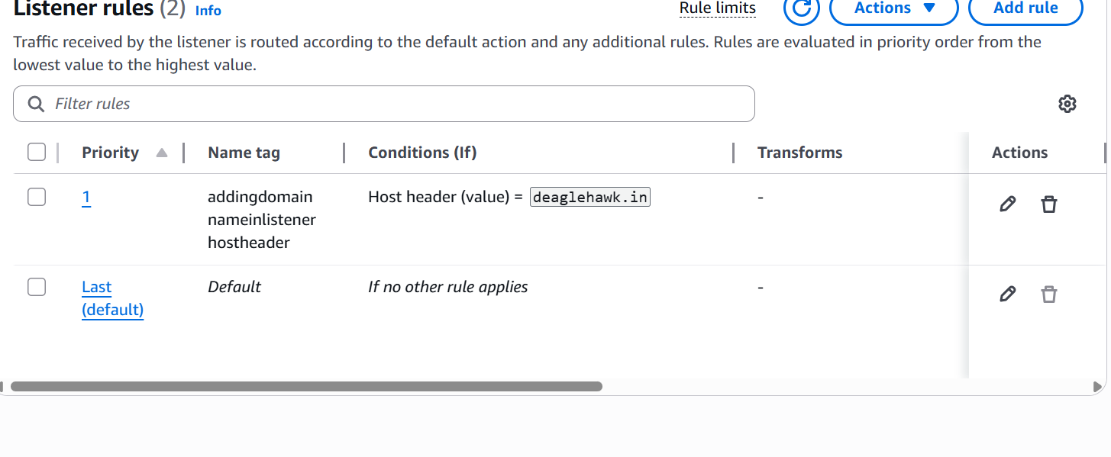

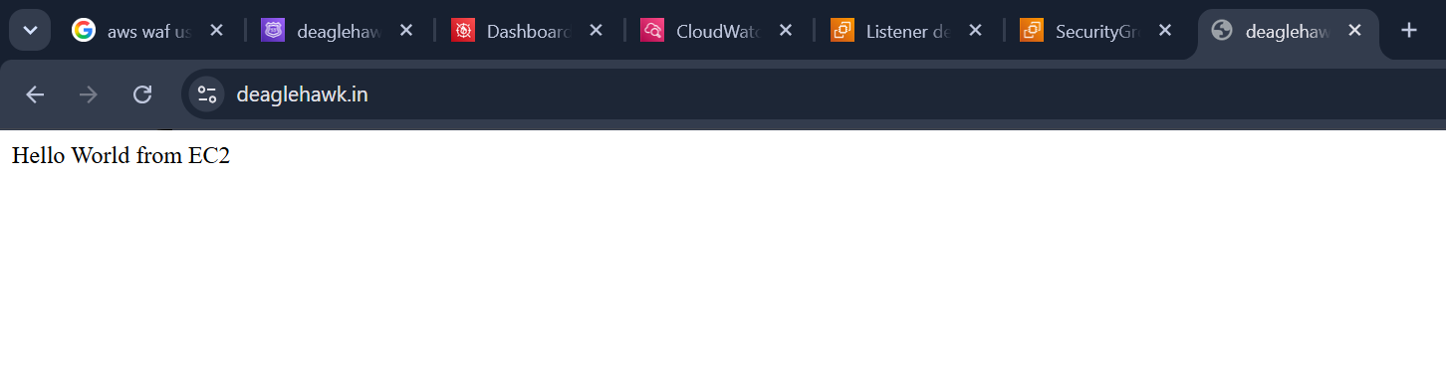

I have added the listener rule so that whoever has my dns link cannot directly access the ec2 instead they will be stopped at this error page which I have customised in deafult rule
And added new rule in that allowed traffic from domain name as shown in above screen shots

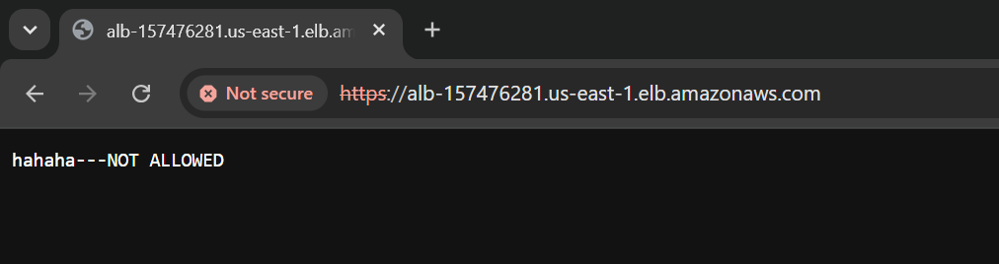
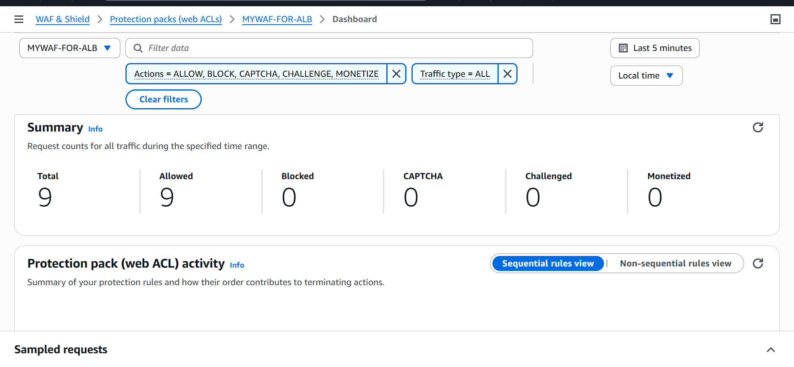

AWS SYSTEMS MANAGER

AWS Systems Manager helps you centrally view, manage, and operate nodes at scale in AWS, on-premises, and multicloud environments. With the launch of a unified console experience, Systems Manager consolidates various tools to help you complete common node tasks across AWS accounts and AWS Regions

We can work on systems manager in the following ways
- Aws cli
- Systems manager console
- Aws sdk
- Aws IOT greengrass v2 console

1. Operations Management
Tools to visualize and manage operational data and incidents across your entire infrastructure fleet.
- Explorer: Displays an aggregated dashboard of operations data, including alerts, compliance status, and resource inventory.
- OpsCenter: Centralizes the investigation and resolution of operational issues (OpsItems) with automated remediation steps.
- Incident Manager: Helps teams prepare for and mitigate critical application availability disruptions with automated incident response plans.
2. Application Management
Services designed to manage application-level configurations, secrets, and environments.
Parameter Store: Offers secure, hierarchical storage for configuration parameters, license codes, and database connection strings.
AppConfig: Allows you to safely deploy dynamic configuration changes to your applications without redeploying code
3. Change Management
Tools to automate and securely execute changes across your infrastructure resources.
Automation: Simplifies common maintenance and deployment tasks by executing pre-built or custom scripts (Runbooks).
Change Manager: Provides an approval workflow engine to track, review, and approve critical infrastructure changes.
4. Node Management
Features designed to securely configure, control, and update physical servers and virtual machines (EC2 instances).
Session Manager: Grants secure, fully audited shell or browser-based access to servers without managing SSH keys or open inbound ports.
Patch Manager: Automates the scanning and deployment of operating system patches across massive server groups.
State Manager: Enforces consistent configurations (e.g., specific software installations or firewall rules) across your instances

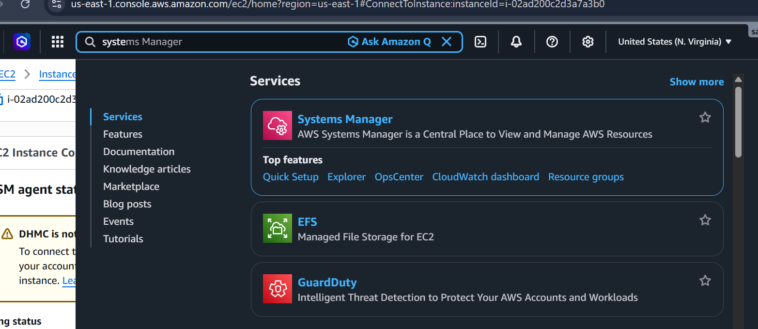

We can see no instances has been seen in the manged nodes

I will be giving iam access to ssm for ec2

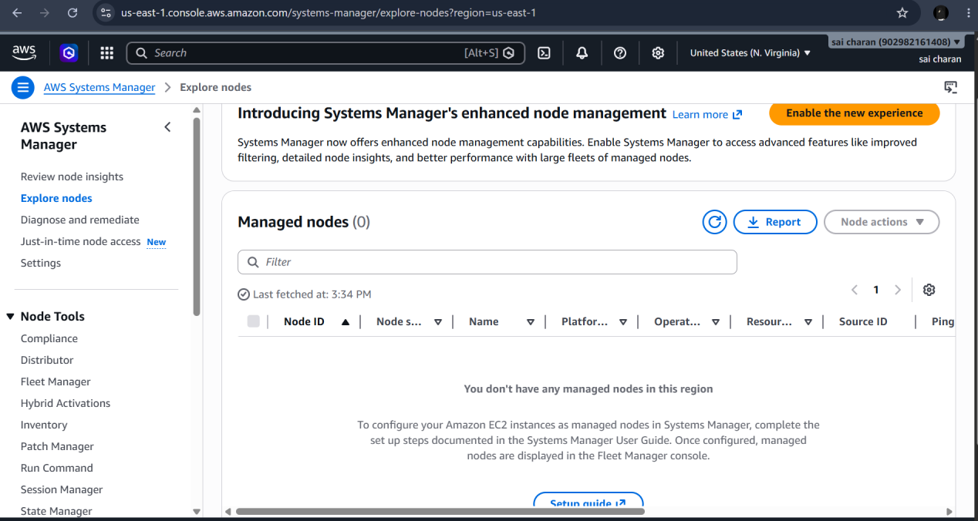

After giving the iam role to ec2 for amazonssminstancecore and attaching the role for ec2 instance
Then the ssm will be active
If dhmc is inactive then go to fleet manager in systems manager and enable

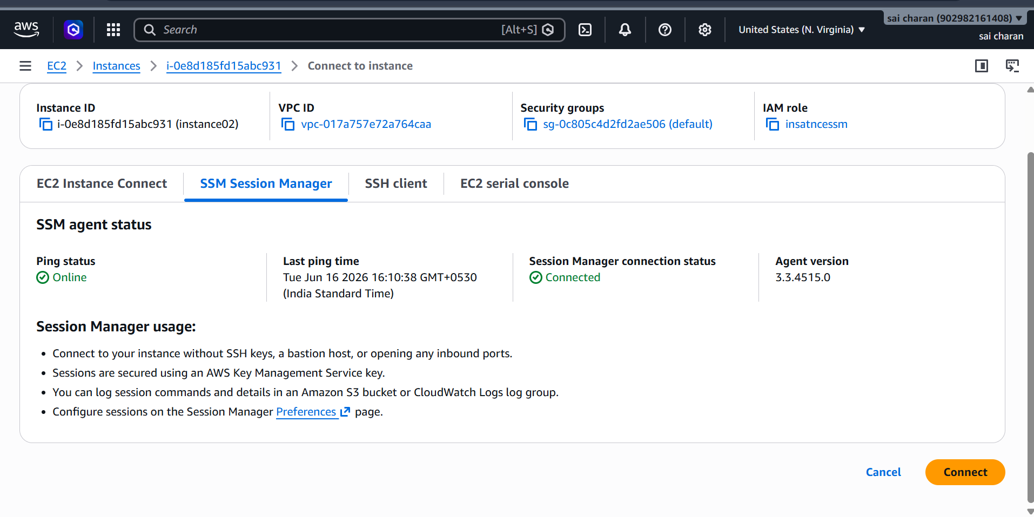

Now we can see the ssm console for our ec2 instance without keypair

We can use the ssm terminal without keypair

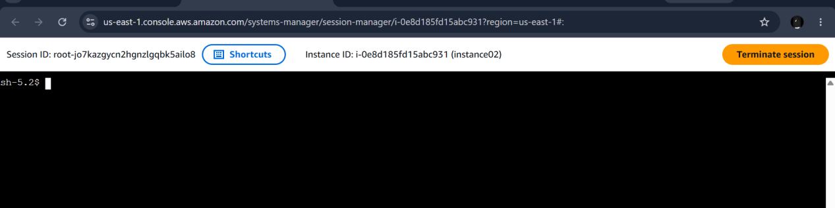

Iam using run command to install services in instances through run command

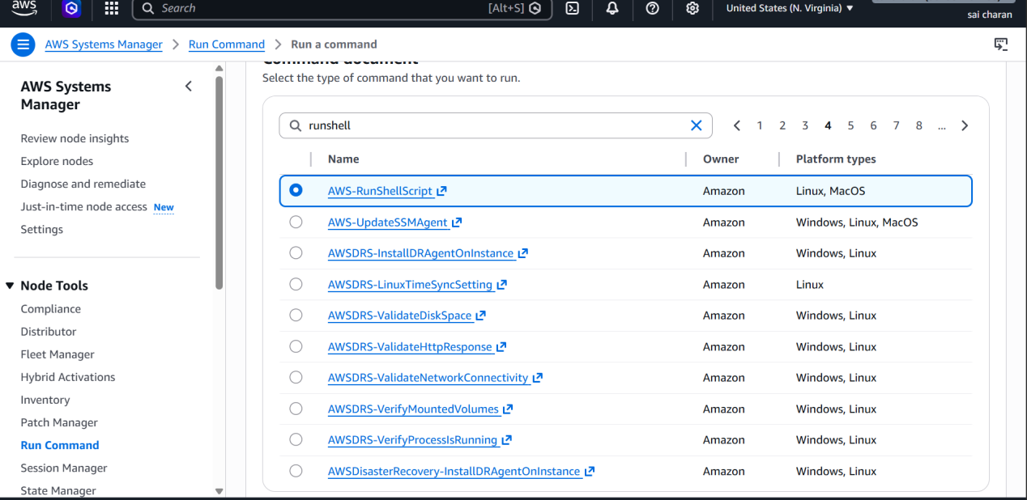

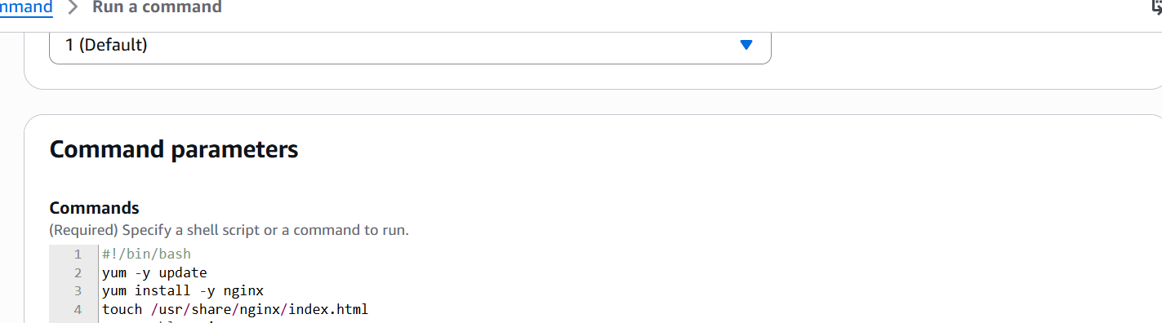

Now with the run command the nodes in ssm should run the command parameters

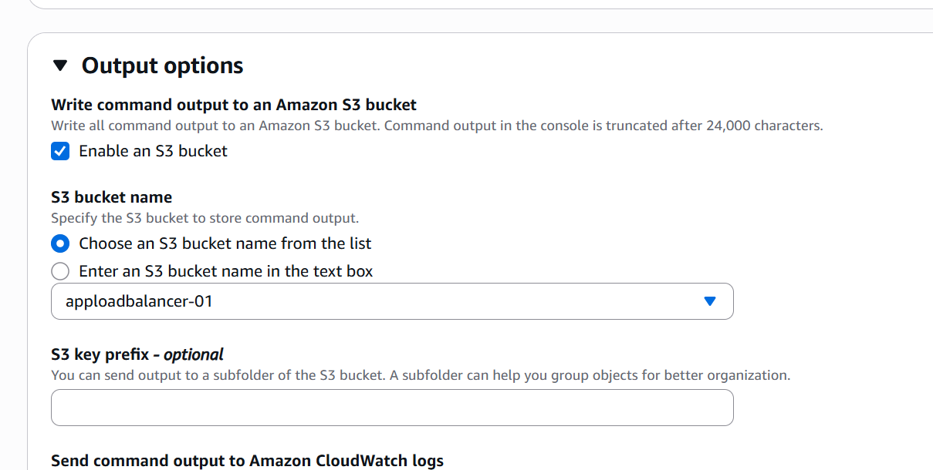

We can also store the output to s3 bucket

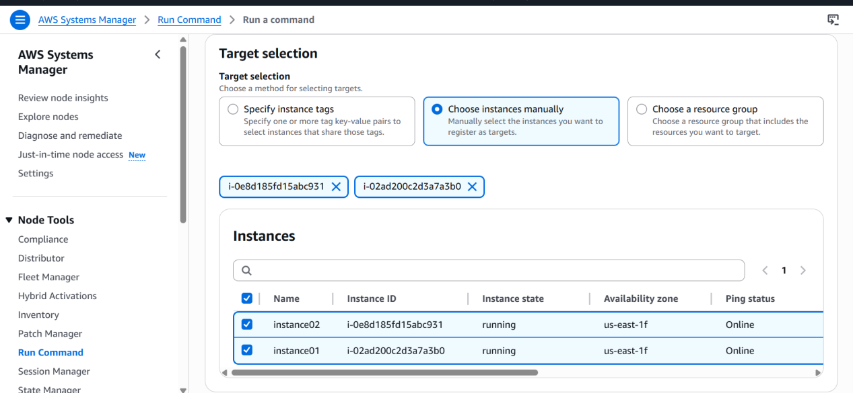

We select instances manually or using tags

Using command parameters I had installed nginx and created a new index.html file For 2 instances

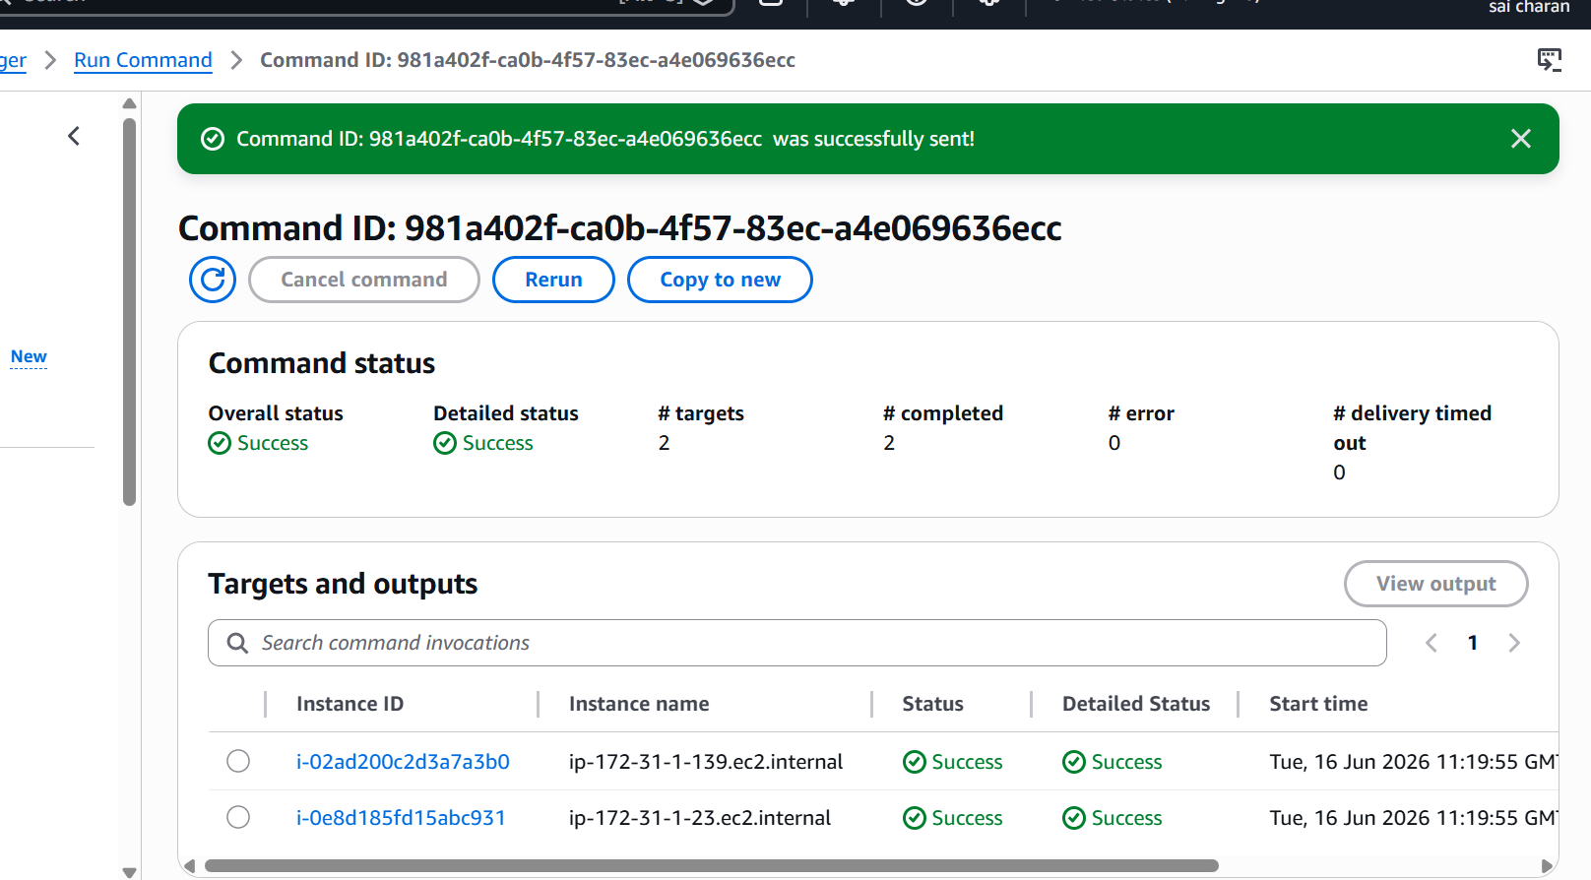

After running the command if the command is executed then it show success

